1. **Where are items stored and if they were rearranged, could a warehouse be eliminated?**
2. Finding the items and its location :

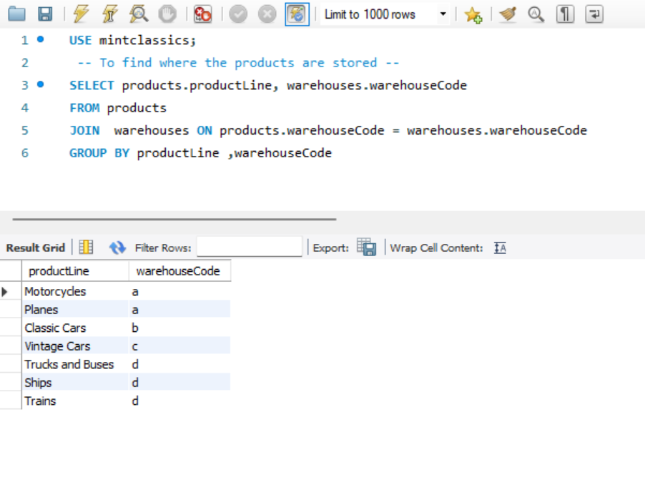

1. To find the total quantities of each item :

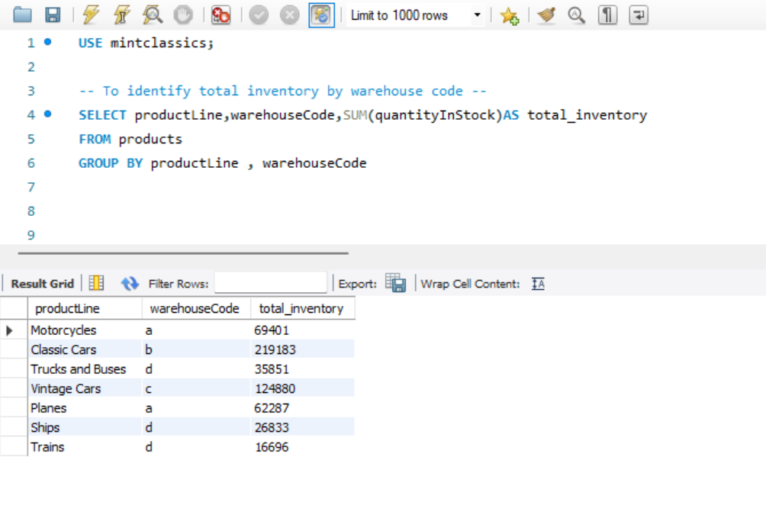

1. Identifying warehouses with minimum total quantity and that may be candidates for elimination :

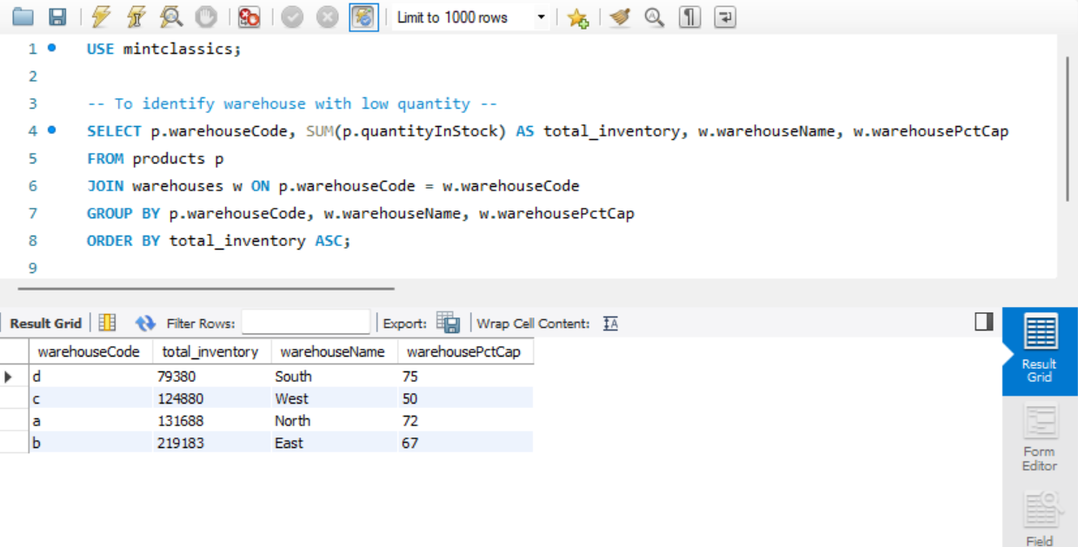

**South warehouse profit margin:**

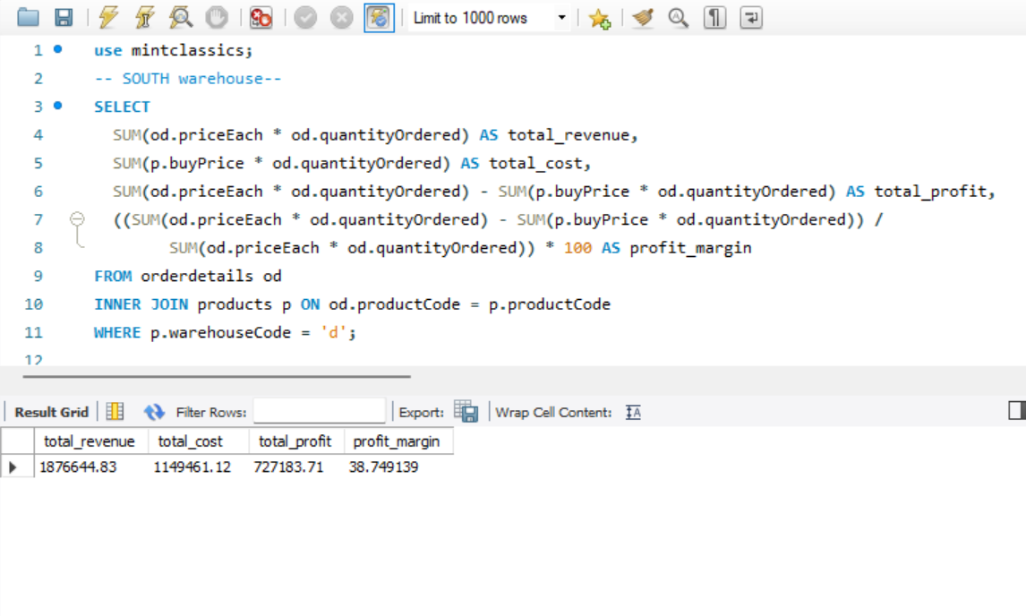

**West warehouse profit margin:**

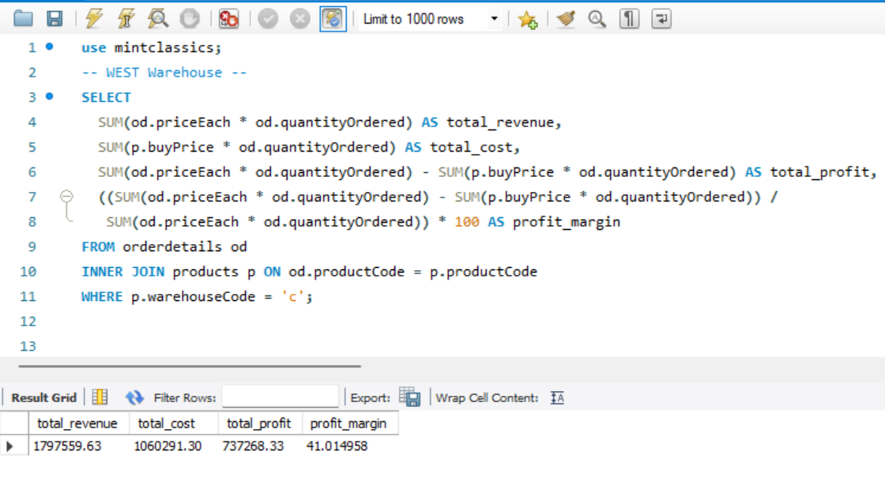

**Analysis of warehouse data revealed that the "WEST" warehouse, despite having a lower storage capacity of 50% compared to other facilities, exhibits a higher profit margin of 41%. Conversely, the "SOUTH" warehouse possesses a limited inventory and demonstrates a lower profit margin of 38%. Merging these two warehouses presents an opportunity to eliminate one facility while maintaining profitability.**

1. **How are inventory numbers related to sales figures? Do the inventory counts seem appropriate for each item?**
2. To calculate inventory turnover :

Inventory turnover: How often inventory is sold and replaced within a specific period.

Inventory turnover = cost of goods sold / average inventory

In this mint classics database, cost of goods sold is calculated by SUM (quantity ordered) and average inventory is calculated by SUM (quantity in stock)

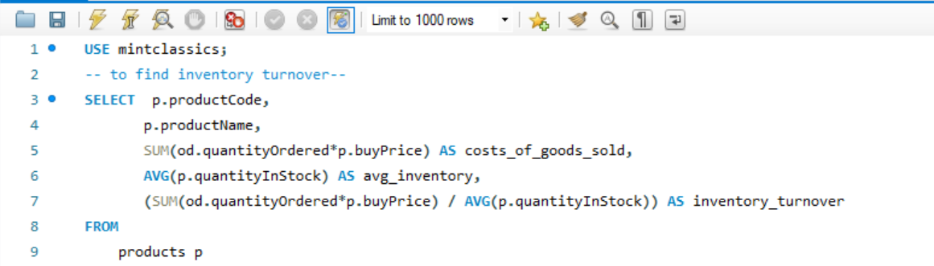

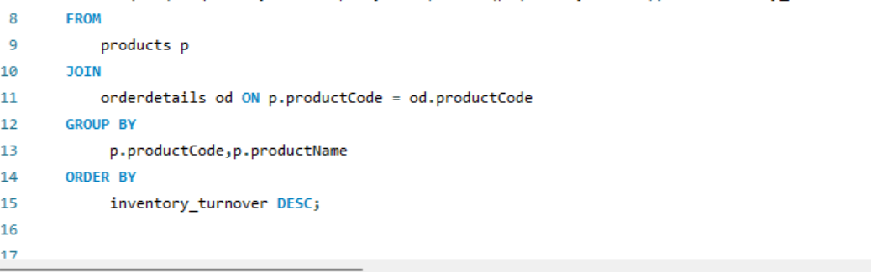

**RESULT:**

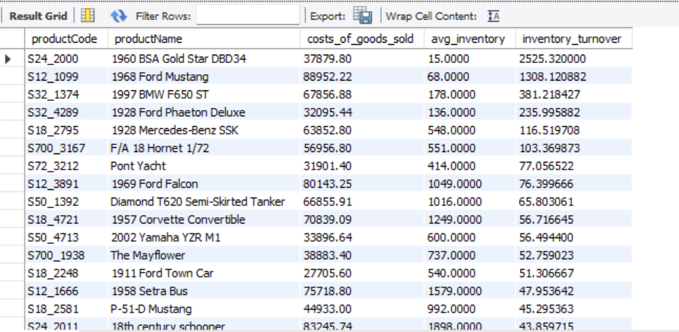

High inventory turnover indicates the faster movement of the products in the inventory and better sales performance compared to others.

Top 5 products with the high inventory turnover:

These products demonstrate strong sales performance and efficient inventory management.

**RESULT:**

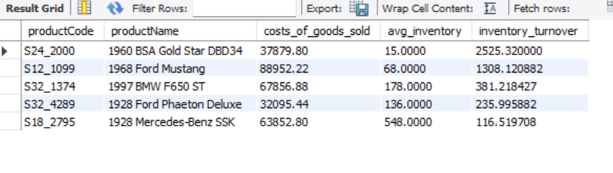

1. Analyse Sales Trend :

* Assumption: quantity in stock < Sum (quantity ordered) is considered ‘Stock Out’
* Assumption: quantity in stock < Sum (quantity ordered) is considered ‘Overstock’
* Inventory levels for these products require adjustment to prevent lost sales or unnecessary storage costs

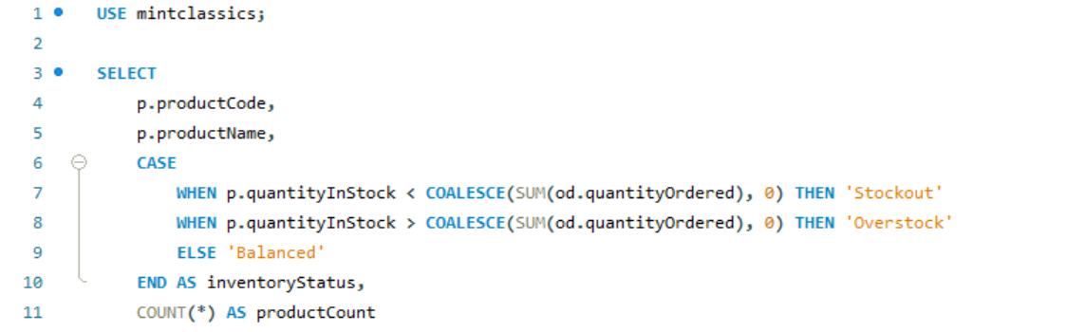

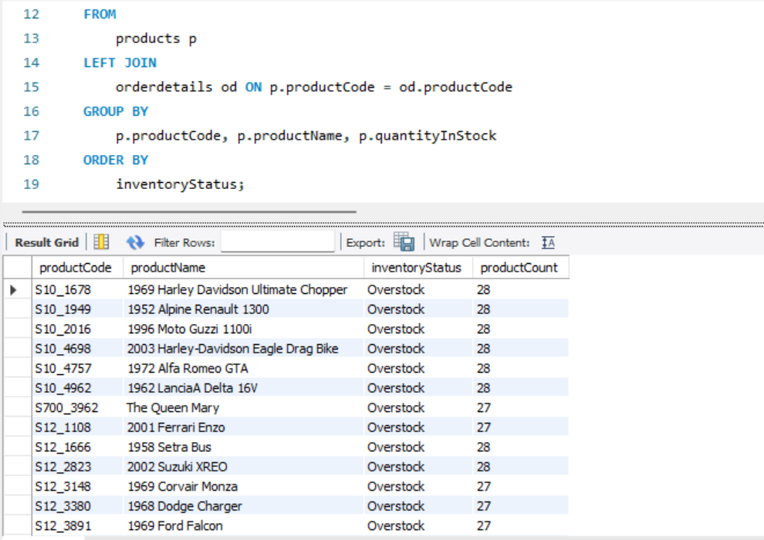

1. Days of inventory on hand ( DOOH) :

DOOH = Quantity in stock / Average Daily Sales

The DOOH figure represents days in stock, and is a major metric for inventory management which directly deals with the number of stocks you have on hand. Basically, it gives you an average number of days that takes for selling the entire stock of a particular product.

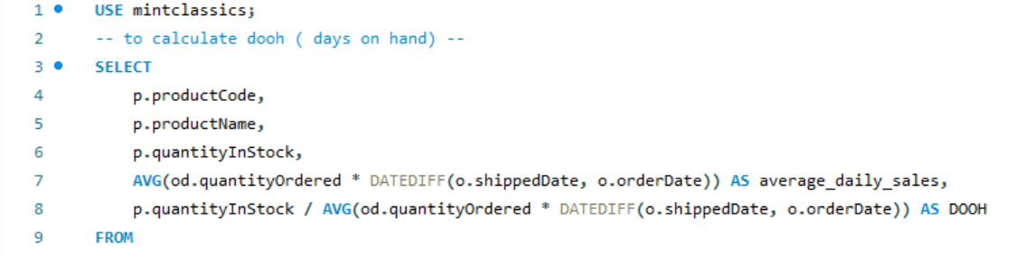

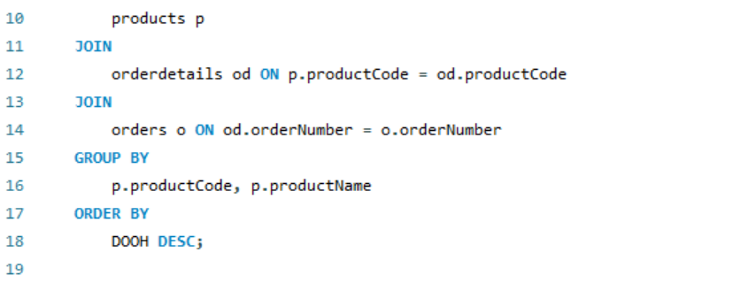

**Top 10 products with high DOOH (days on hand):**

**RESULT:**

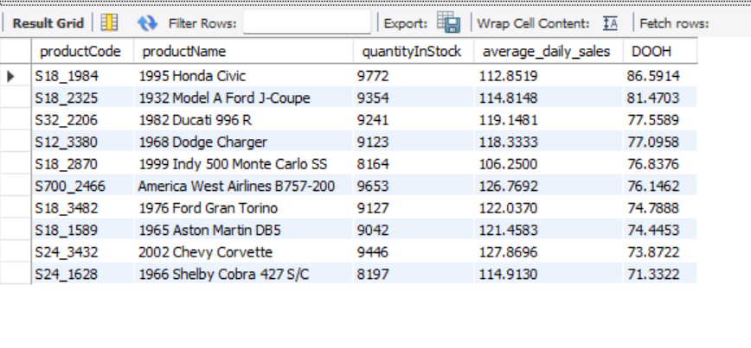

High DOOH:

Higher number of inventory days, meaning it takes longer time to sell those products. This implies that:

1. Excessive Inventory: Possession of more stocks than needed may result in storage costs and eventually fall into disuse or become outdated.
2. Slow moving products : Products that are selling slowly may cause high DOOH.

**TOP 10 products with low DOOH:**

**RESULT:**

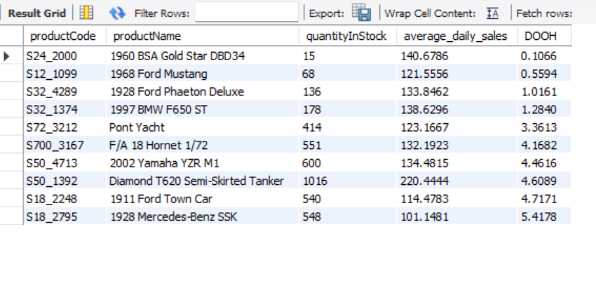

Lower DOOH**:**

Lower number of inventory days indicates that products are selling faster. This implies that:

1. High popular products: Products that are highly popular and selling faster leads to lower dooh.
2. Insufficient inventory: Lower dooh may also indicate that shortage of certain products.
3. **Are we storing items that are not moving? Are any items candidates for being dropped from the product line?**

To find items that are not moving can be answered by analysing:

* + - * + Inventory turnover
        + Product with high inventory level
        + Inventory holding cost or inventory value
        + Profitability of each product
* Inventory Turnover:
* Inventory turnover is calculated as the cost of goods sold divided by the average inventory.
* High inventory turnover indicates efficient inventory management and strong sales performance.
* Low inventory turnover suggests slow-moving products or excessive inventory levels.

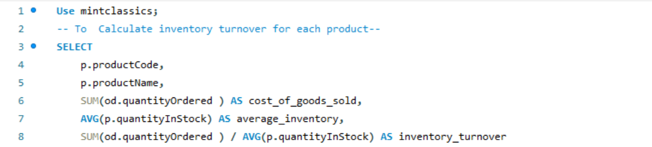

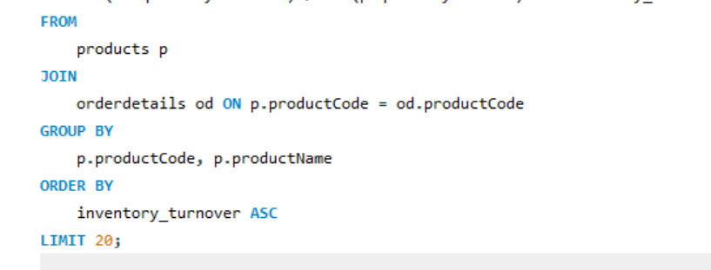

**RESULT:**

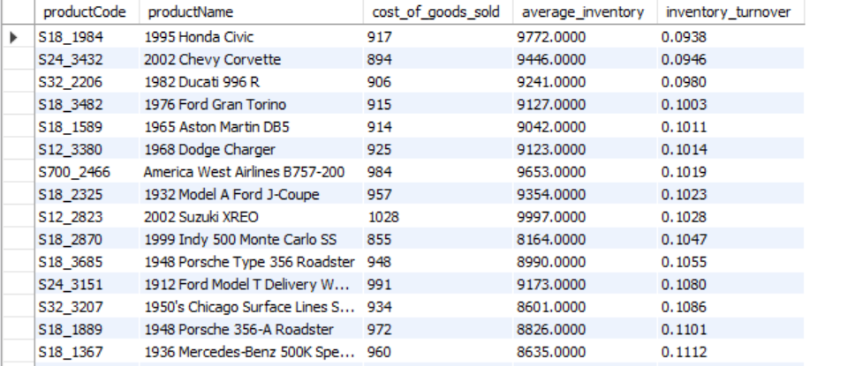

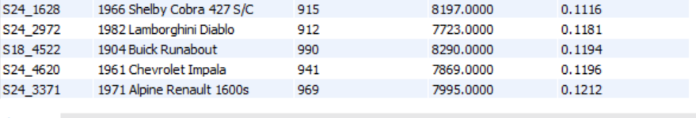

* **This list reveals that top 20 items that exhibit significantly low turnover rates. These products are classified as slow moving or stagnant, indicating potentially sluggish sales.**
* High Inventory level :

Inventory level analysis identifies products with high inventory levels, further indicating slow movement or declining sales.

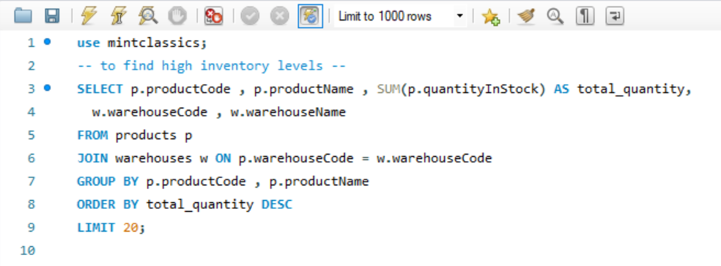

**RESULT:**

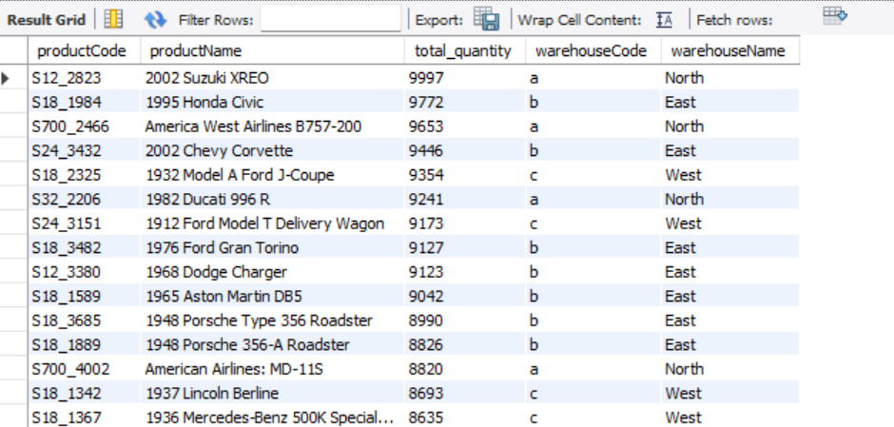

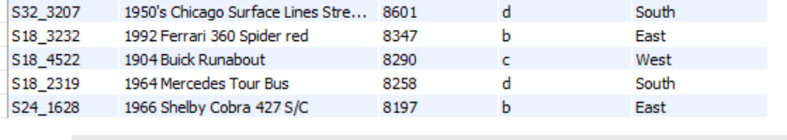

* Inventory holding cost :
* Inventory cost with low sales aids in identifying items to be dropped.
* Products with high inventory costs and low sales are prime candidates for inventory reduction or product line elimination.

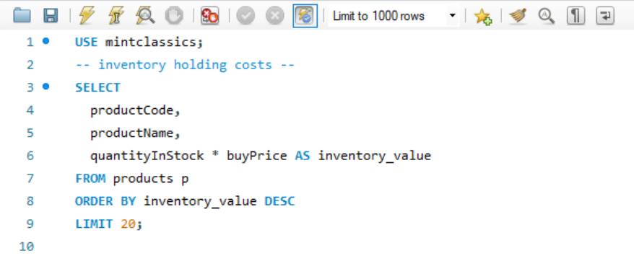

**RESULT:**

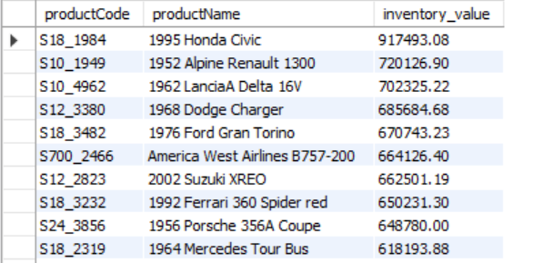

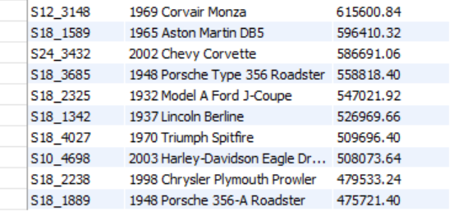

* Profitability :
* Profitability analysis assesses the revenue and cost associated with each product.
* Products with low or negative profitability require immediate attention to improve their financial performance.
* Products with low or negative profitability: This list identifies products that are not contributing positively to the company's bottom line.

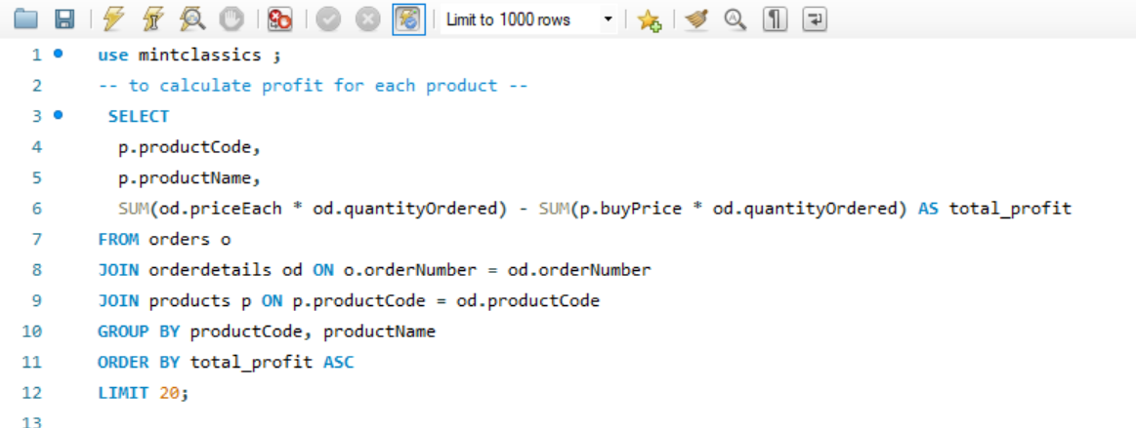

**RESULT:**

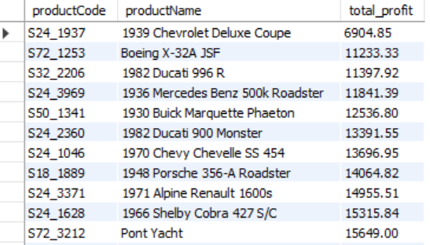

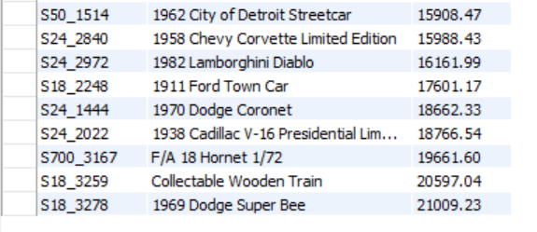

**(b) Items that candidates for dropping based on the inventory turnover, inventory level, inventory value and profitability:**

Based on the combined analysis of inventory turnover, inventory level, inventory holding cost, and profitability, eleven (11) products are identified as potential candidates for removal from the product line. These products include:

|  |  |
| --- | --- |
| **PRODUCT CODE** | **PRODUCT NAME** |
| S18_1984 | 1995 Honda Civic |
| S18_3685 | 1948 Porsche Type 356 Roadster |
| S24_3432 | 2002 Chevy Corvette |
| S32_2206 | 1982 Ducati 996 R |
| S700_2466 | America West Airlines B757-200 |
| S18_3482 | 1976 Ford Gran Torino |
| S12_3380 | 1968 Dodge Charger |
| S18_2325 | 1932 Model A Ford J-Coupe |
| S12_2823 | 2002 Suzuki XREO |
| S18_3685 | 1948 Porsche Type 356 Roadster |
| S24_1628 | 1966 Shelby Cobra 427 S/C |

1. **Are some items sold more than others?**

This analyzes product sales data from the Mint Classics database to identify the best-selling items. The result reveals the top 10 items sell significantly more than others do.

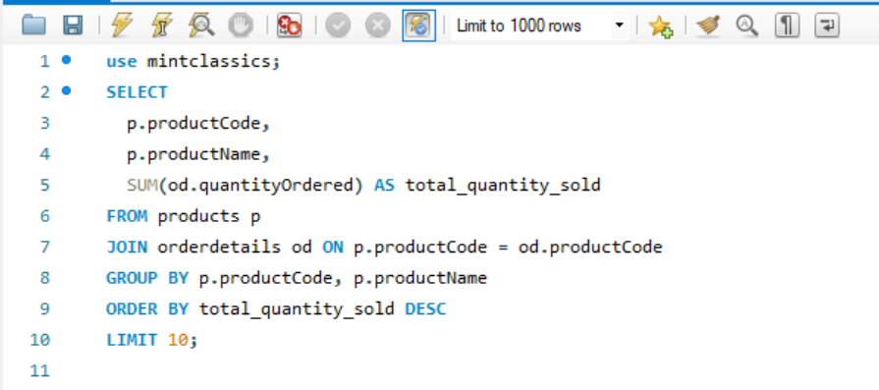

**RESULT:**



